BookTrack
Work Breakdown Structure

Project Planning and Management
- Task 1: Define the project objectives and scope. (Leader)
- Task 2: Assign tasks and responsibilities to all members. (Leader)
- Task 3: Monitor the progress of each member. (Leader)
- Task 4: Coordinate meetings and check project deadlines. (Leader)

User Interface/User Experience Design
- Task 1: Review the approved BookTrack Figma design. (Designer)
- Task 2: Complete the Student wireframes. (Designer)
- Task 3: Complete the Librarian/Staff and Admin wireframes. (Designer)
- Task 4: Check the consistency of buttons, colors, navigation, and layouts. (Designer)

Application Development
- Task 1: Set up the application structure.
  - Sub-task: Prepare the project files and folders.
  - Sub-task: Set up the database connection.
- Task 2: Develop the login system and role-based access.
  - Sub-task: Create access for Student, Librarian/Staff, and Admin.
- Task 3: Develop the book management features.
  - Sub-task: Implement book searching, book details, and shelf locations.
- Task 4: Develop borrowing requests, returns, borrowing history, and overdue tracking. (Programmer)

Quality Assurance and Testing
- Task 1: Prepare the Software Test Plan. (Tester)
- Task 2: Prepare the Test Case Matrix. (Tester)
- Task 3: Test available features and record the actual results. (Tester)
- Task 4: Identify errors and check whether corrections work properly. (Tester)

Technical Documentation
- Task 1: Update the Software Requirements Specification (SRS). (Documenter)
- Task 2: Add the Software Test Plan and Test Case Matrix to the SRS. (Documenter)
- Task 3: Organize the project schedule, requirements, and supporting documents. (Documenter)
- Task 4: Review the final documents for completeness and proper formatting. (Documenter)

BookTrack
Project Schedule

TASK | ASSIGNEE | START DATE | FINISH DATE | DURATION
Phase 1: Project Planning and Management
Task 1: Review project requirements and scope | Leader | Oct. 12, 2026 | Oct. 12, 2026 | 1 day
Task 2: Assign member responsibilities | Leader | Oct. 12, 2026 | Oct. 12, 2026 | 1 day
Task 3: Helps, guide, and review progress and deadlines | Leader | Oct. 12, 2026 | TBL | TBL
Phase 2: UI/UX Design and Requirements Review
Task 1: Review existing Figma wireframes | Designer | Oct. 12, 2026 | TBL | TBL
Task 2: Check Student, Librarian, and Admin page requirements | Programmer | Oct. 12, 2026 | TBL | TBL
Task 3: Review Design changes and requirements | Designer | Oct. 12, 2026 | TBL | TBL
Task 4: Double check wireframe | Designer/Programmer | Oct. 13, 2026 | TBL | TBL
Phase 3: Quality Assurance and Testing Documentation
Task 1: Prepare the Software Test Plan | Tester | Oct. 12, 2026 | Oct. 13, 2026 | 2 days
Task 2: Prepare the Test Case Matrix | Tester | Oct. 12, 2026 | Oct. 13, 2026 | 2 days
Task 3: Present testing documents for instructor checking | Tester | Oct. 14, 2026 | Oct. 14, 2026 | 1 day
Phase 4: Technical Documentation and Final Review
Task 1: Update the SRS and incorporate the test documents | Documenter | Oct. 12, 2026 | Oct. 13, 2026 | 2 days
Task 2: Review and revise documents based on feedback | Documenter | Oct. 12, 2026 | Oct. 14, 2026 | 2 days
Task 3: Final checking and submission preparation | Leader | Oct. 14, 2026 | TBL | TBL

BookTrack
User Flow Diagram

MAIN USER FLOW (LOGIN and SIGNUP)

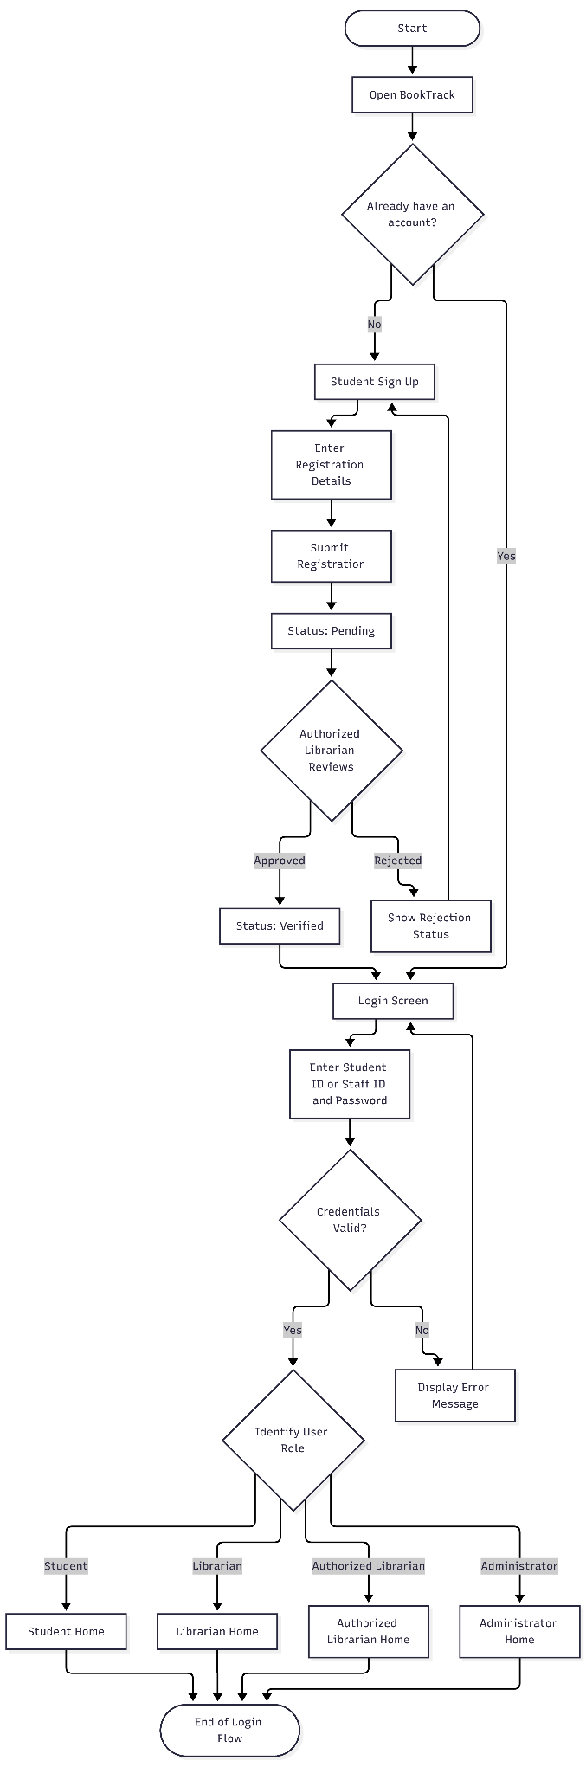
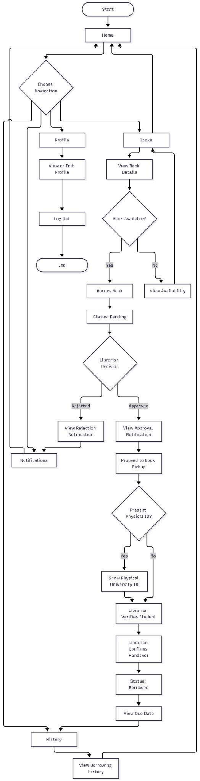
STUDENT USER FLOW
LIBRARIAN USER FLOW
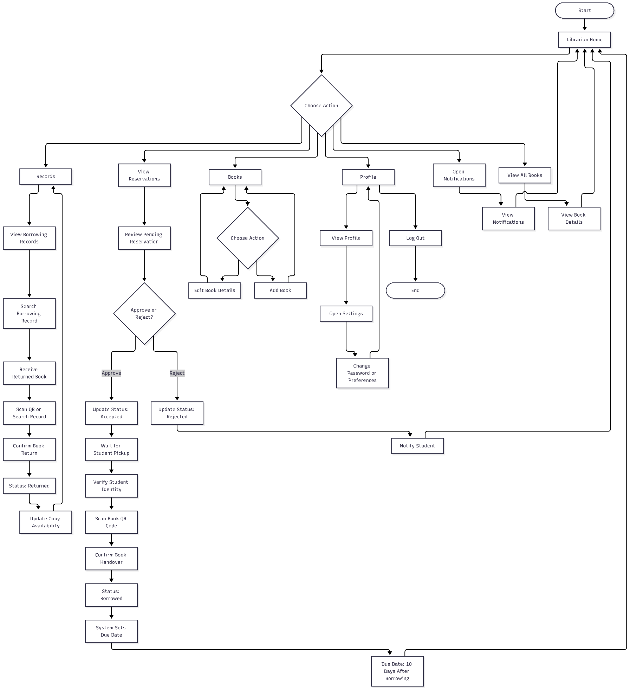

AUTHORIZED LIBRARIAN (Approving and Rejecting Users)

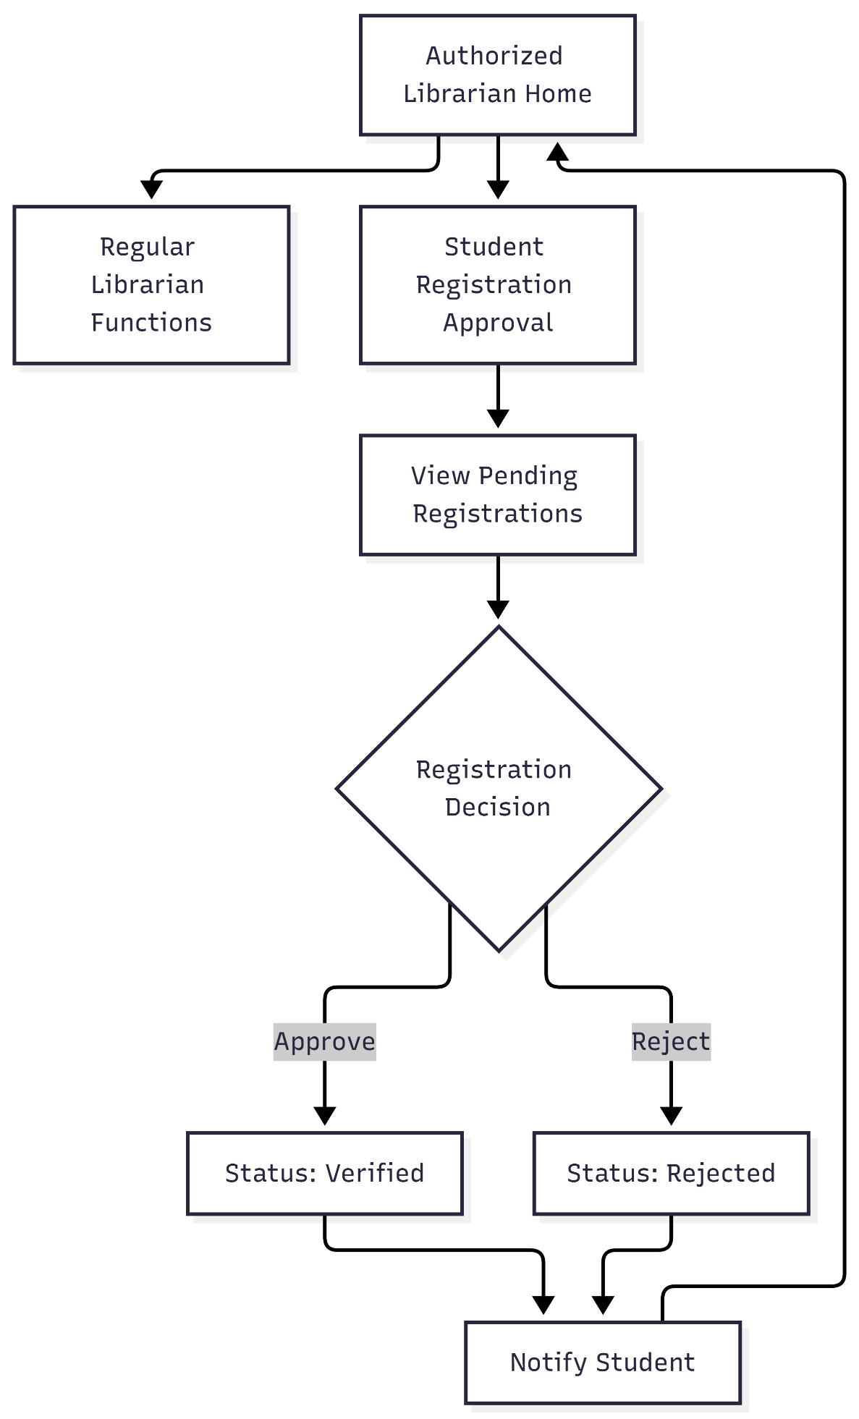

ADMIN USER FLOW
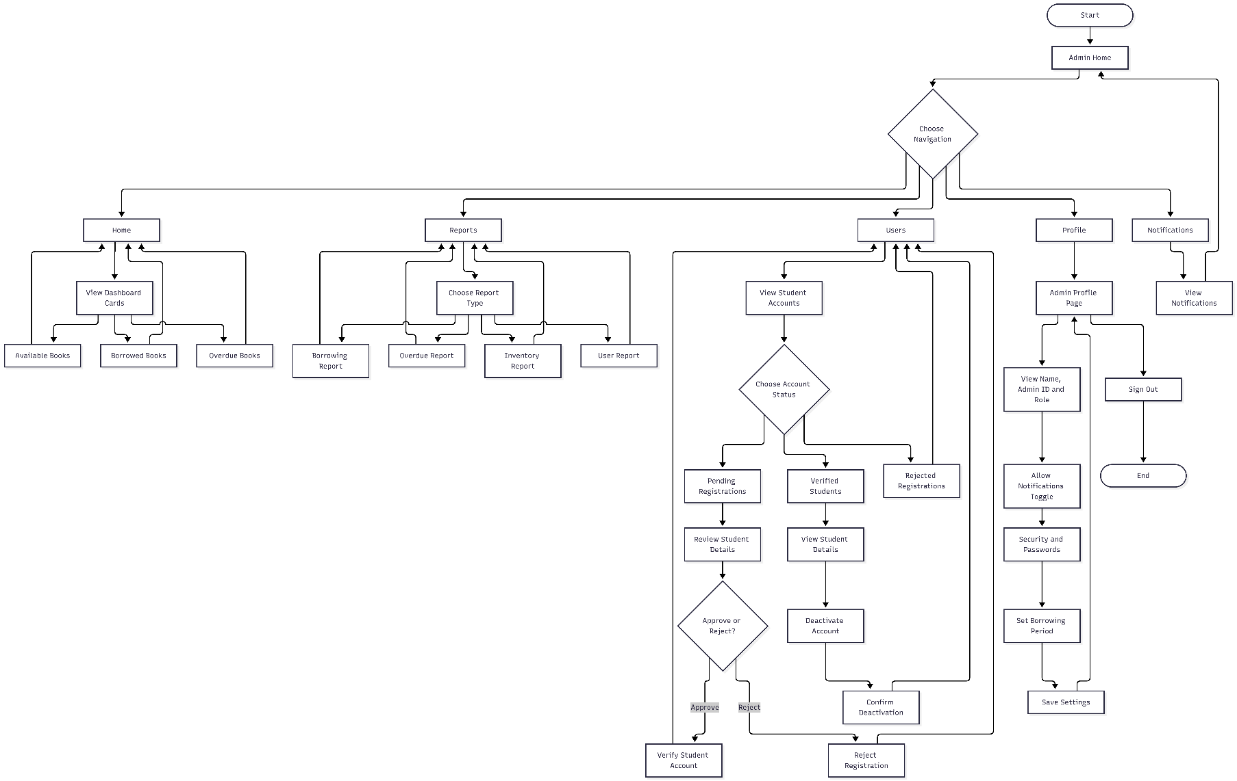

BookTrack
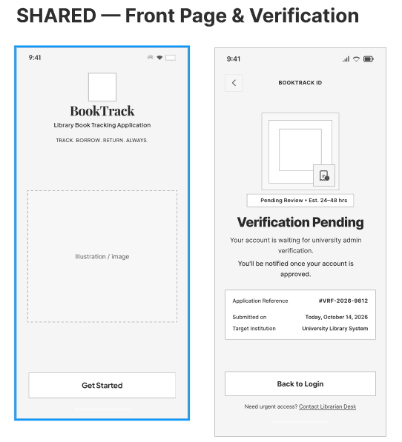
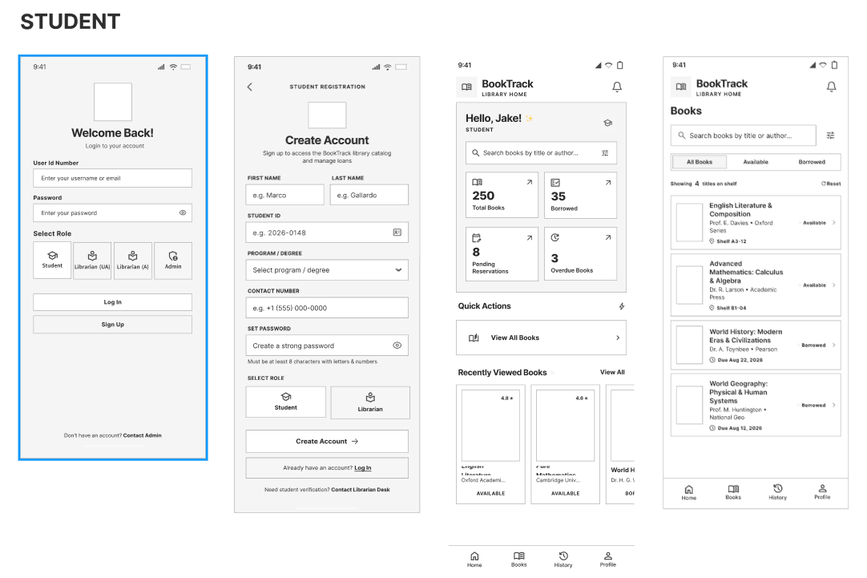
Wireframe
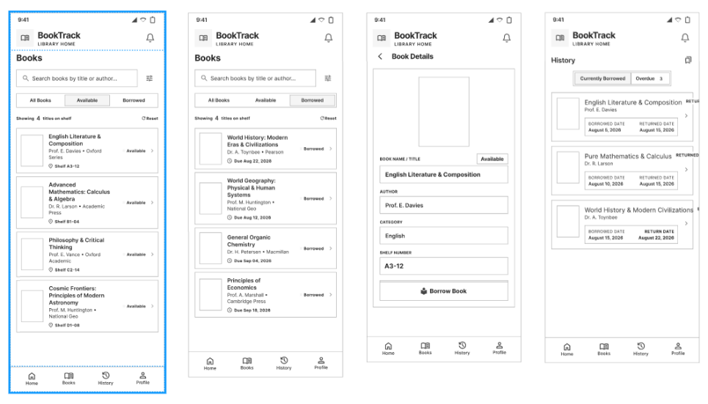
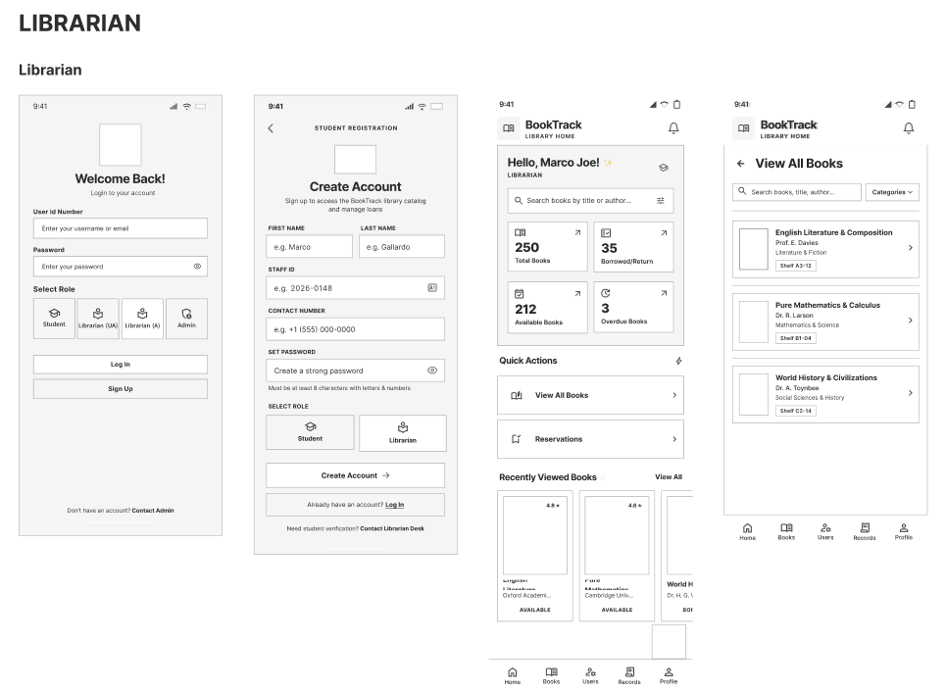
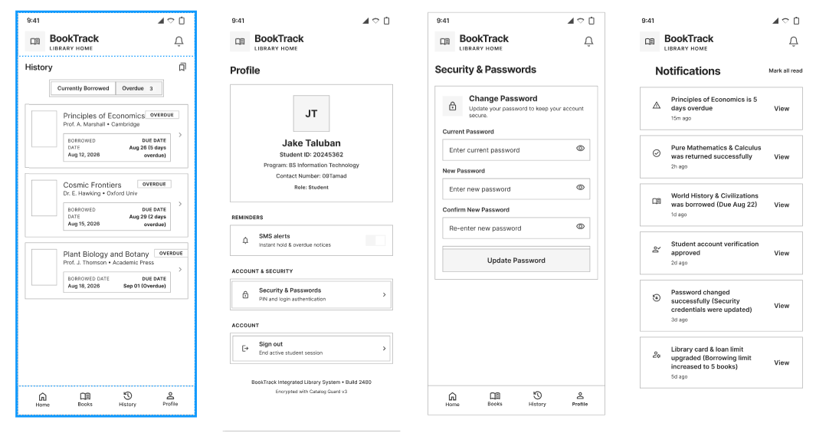
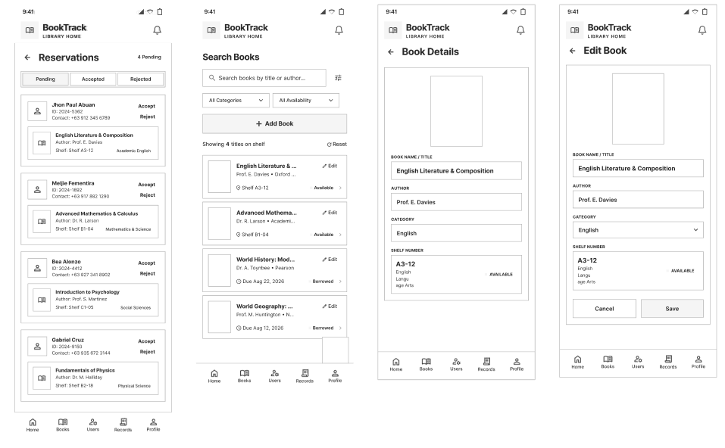
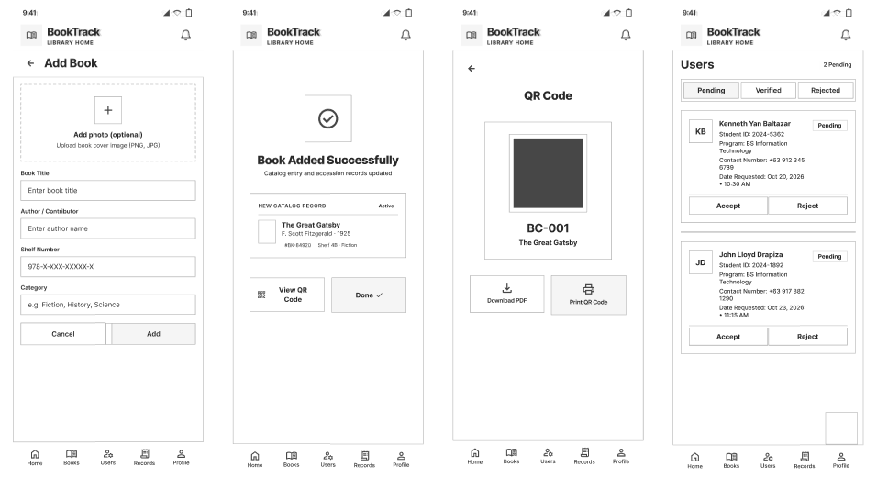

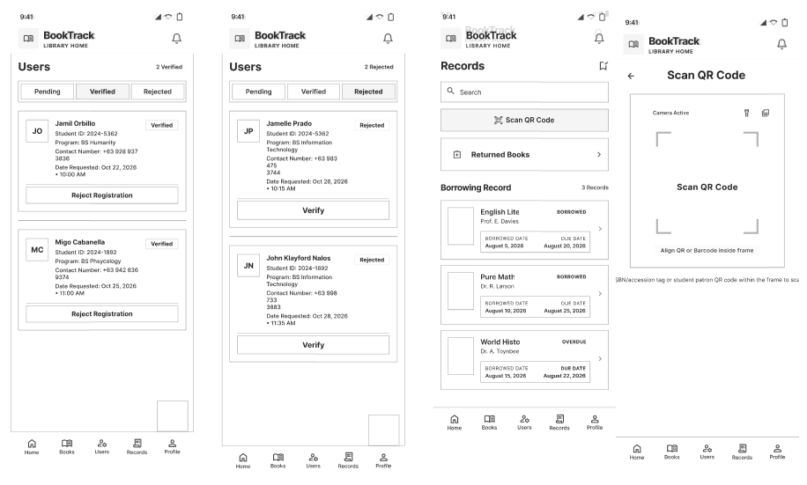
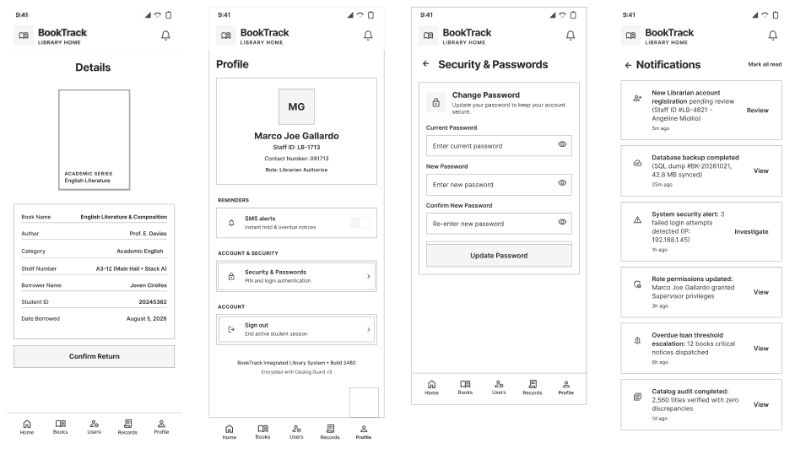

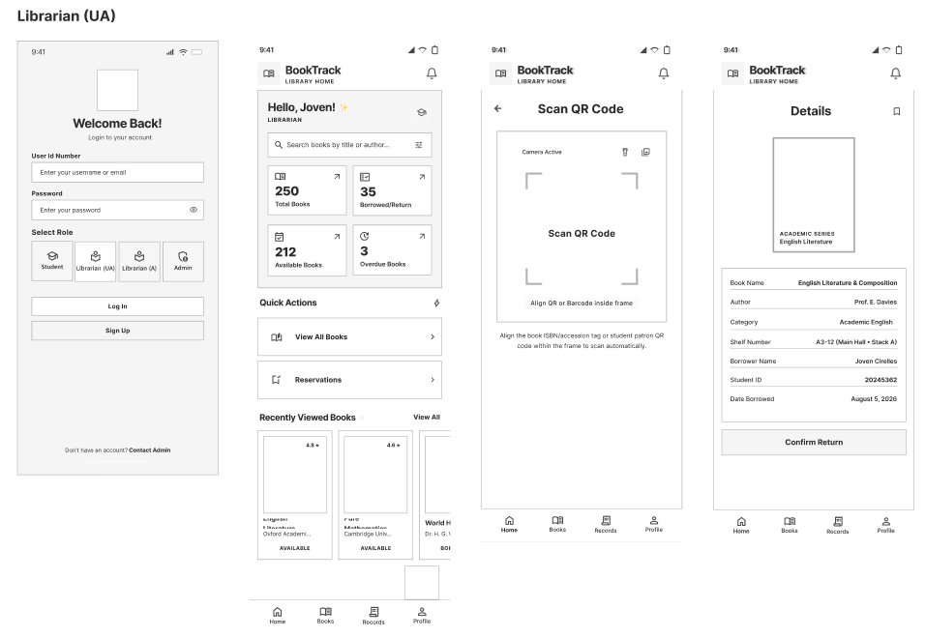
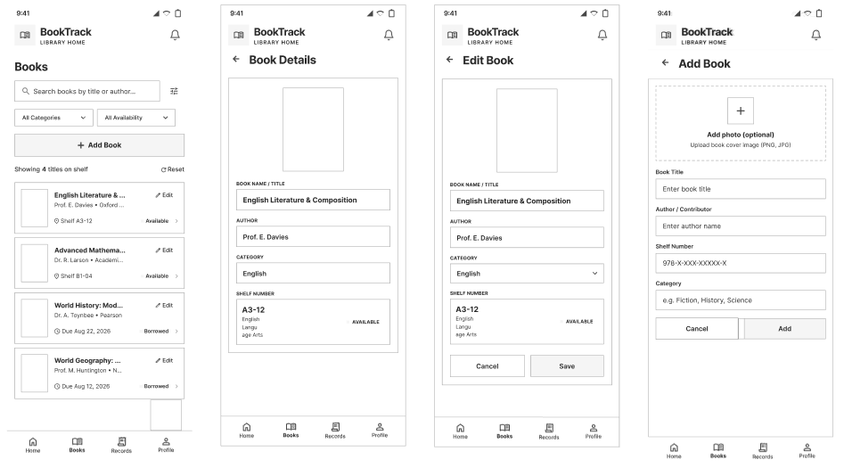

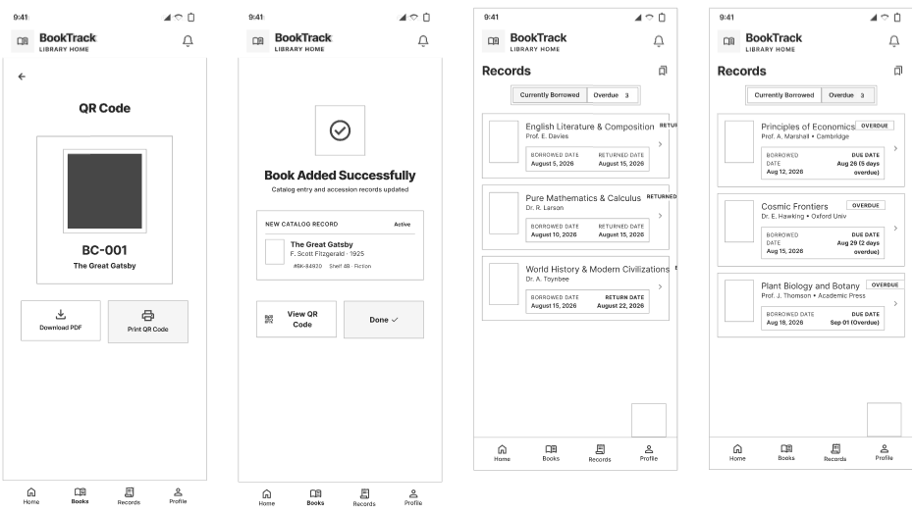

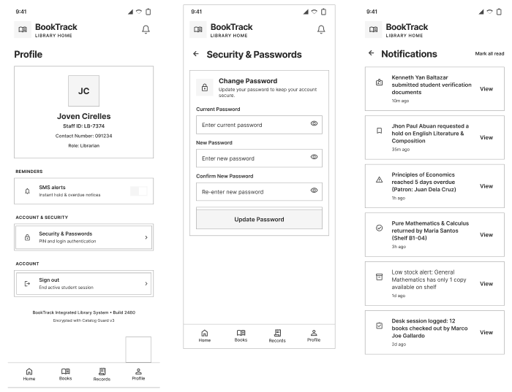
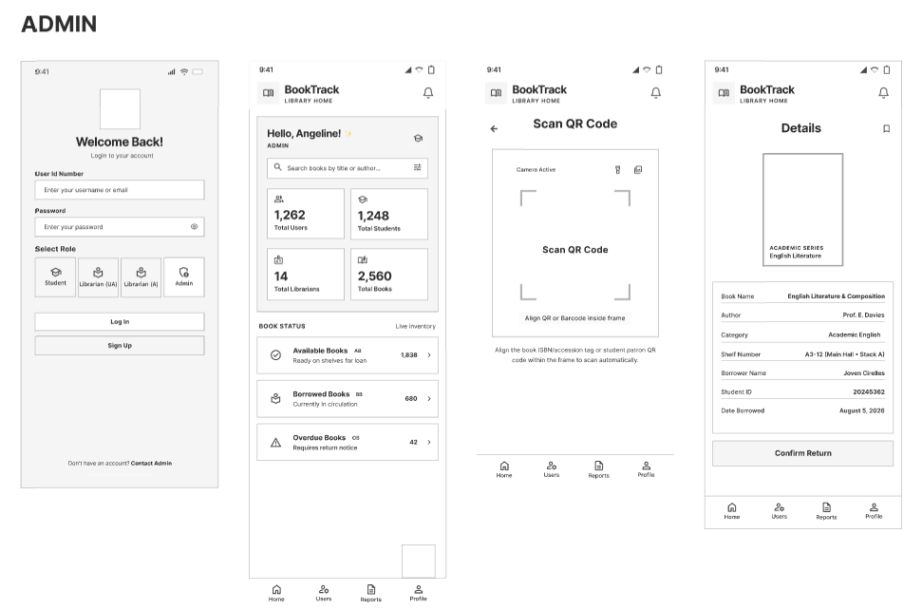
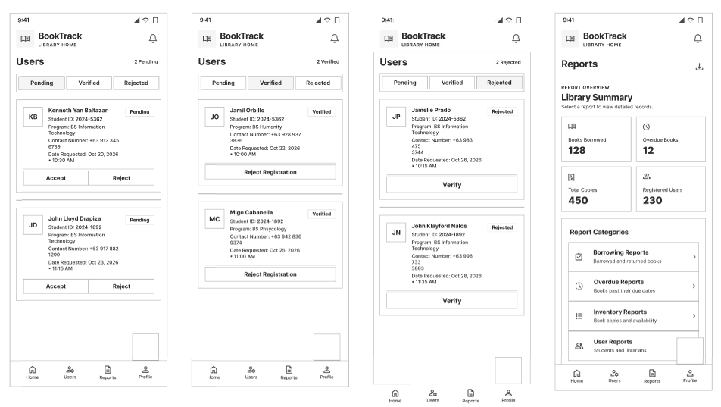

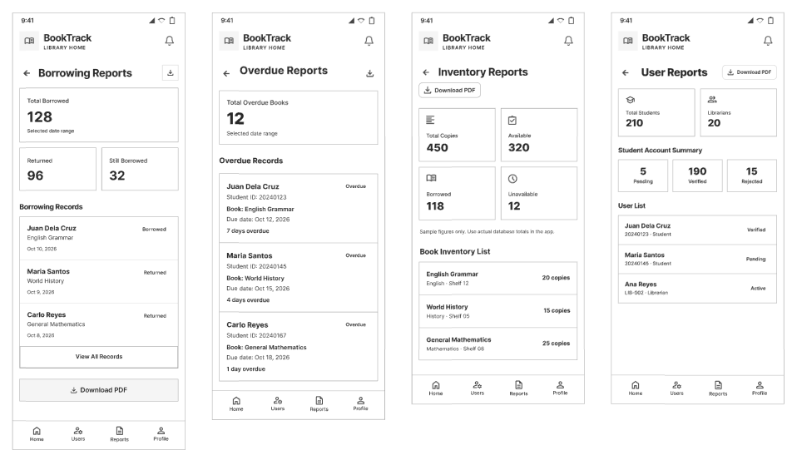

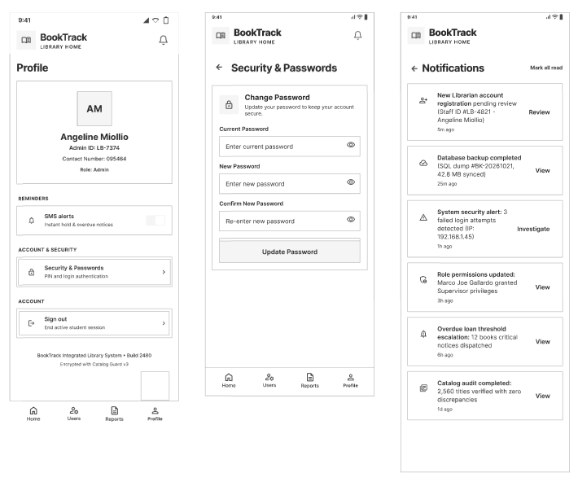

BookTrack
Repository Setup

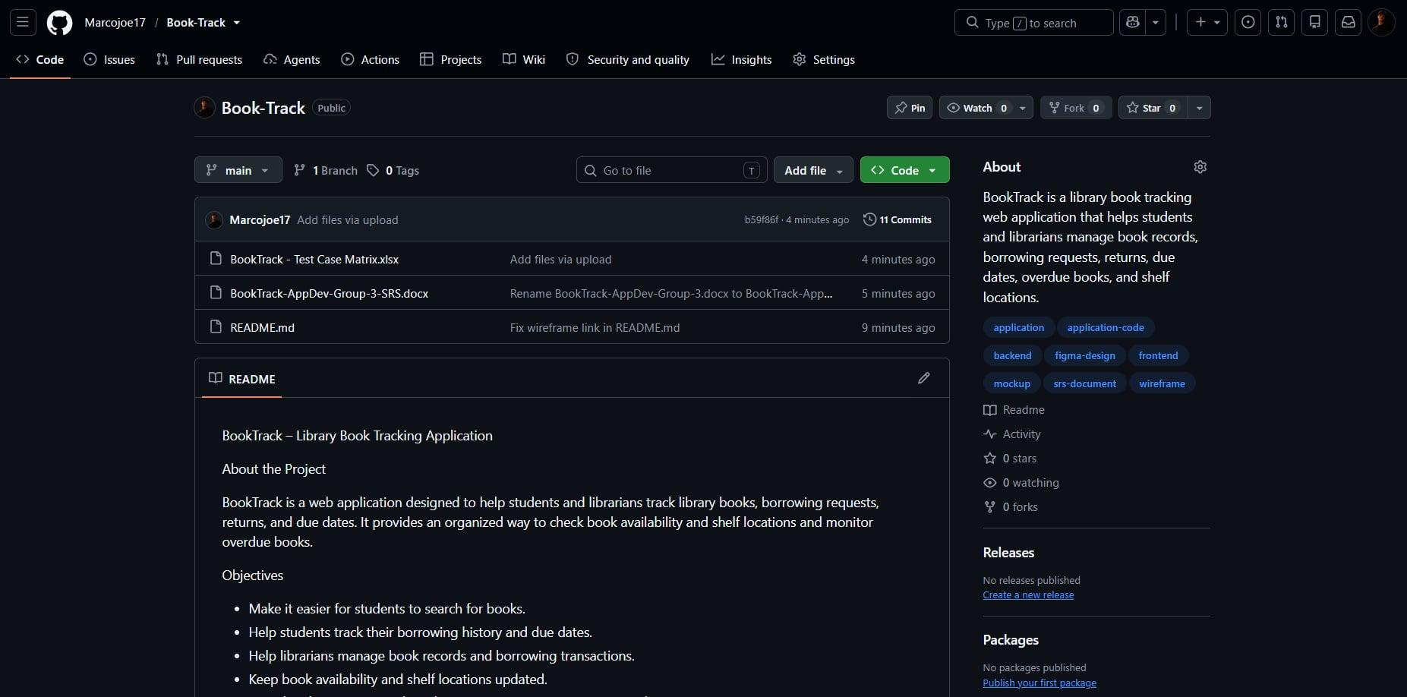
https://github.com/Marcojoe17/Book-Track

BookTrack
Test Plan Strategy
Framework: Flutter | QA Tester: [Chris Joven C. Cirelles]
Target Platform: Web browser (desktop and mobile screen sizes) | Timeline: 1-6 week
1. Objective & Scope
Ensure BookTrack operates reliably, matches the SRS, and carries out the core borrowing and returning flows for Students, Librarians and Admins without critical bugs before final release. The 121 test cases in the Test Case Matrix are based only on the SRS. Column B of the matrix gives each case its requirement, FR-01 to FR-18 or a non-functional category (Usability, Security, Maintainability, Performance, Reliability and Availability, Compatibility), and the SRS Traceability sheet shows the coverage. Features the SRS does not mention are not tested; their old cases are kept on the Removed sheet of the matrix.
In-Scope (What We Test):
- User Registration, Authentication and Access Control: Student sign-up and registration approval (FR-01, FR-05), login for the Student, Librarian and Admin roles, sign out (FR-18), and what each role can and cannot open.
- Core App Features & Business Rules: Book records and search, borrow requests, QR code handover and returns, due dates and overdue status, borrowing records and history, user management, reports, borrowing period configuration, notifications, profile and password management (FR-03, FR-04 and FR-06 to FR-17).
- Role-Based Navigation and Layout: Each role sees navigation and pages for its own functions, with a consistent layout within the role.
- Non-Functional Requirements: Usability, security, performance, reliability and availability, and compatibility, checked manually. Maintainability is checked by reviewing the code structure and database design.
Out-of-Scope (What We Do NOT Test): Proposed; the team should confirm.
- Automated Stress / Load Testing
- Code-level Unit Testing
- Forgot Password (not in the SRS)
- Features the SRS does not mention, such as shelf location, a borrowing limit, activity logs and dashboards
2. Testing Approach
Testing is manual: testers follow the matrix steps in a web browser and mark each case PASS, FAIL or BLOCKED (cases not yet run stay NOT RUN). Critical-severity cases (core features and security) run first.
- UI/UX Testing: Verify that pages, buttons, forms and messages are clear and consistent within each role, as the SRS Usability requirements describe. Visual styling such as colors and typography is not checked by the matrix.
- Functional Testing: Verify registration and login rules, form validation, borrow request approval and rejection, QR code handover, due dates, overdue status, returns, reports, notifications and role permissions, using positive, negative and boundary cases. Export and read/unread status are tested only if implemented.
- Integration Testing: Verify that data entered on one screen appears correctly on the others and is saved in the database, for example a return updating the book’s availability, the student’s history and the librarian’s lists.
- Non-Functional Testing: Verify security, performance, compatibility, usability and reliability. The SRS gives no numbers for performance, so the team uses its own target (2 seconds).
- Regression Testing: After defects are fixed, re-run the Critical-severity cases and the main path (log in, borrow request, approval, QR handover, return) to make sure nothing else broke.
3. Testing Environment & Tools
- Browsers and Devices:
  - At least two compatible web browsers on a desktop or laptop
  - Mobile screen size: a phone or a narrow browser window to check that the layout adapts. A device with a working camera is needed for QR code scanning. Browsers and devices to confirm.
- Tools:
  - Defect Tracker: The Defect Log tab of the matrix workbook
  - Requirements Source: The BookTrack SRS (FR-01 to FR-18 and the non-functional requirements)
- Test Environment: A dedicated test build of BookTrack and its backend, never live library data. An API tool such as Postman is needed for the one access-control check that cannot be done from the screens (TC-ACC-002), and database access is needed to check that passwords are stored hashed (TC-NFR-011). To confirm: how testers open the build, the backend address, and which database is used.
- Test Data: Student 1 (has Book B), Student 2 (overdue Book C), Student 3 (deactivated), Student 4 (no loans), Students 6 to 10 (registrations in Pending, Verified and Rejected status), Librarian 1 (Authorized Librarian), Librarian 2 (Unauthorized Librarian) and Admin 1. Book A is Available and has a QR code, Book B is borrowed by Student 1 and due in the future, and Book C is borrowed by Student 2 and overdue. The default borrowing period is 10 days (SRS FR-14). Reset the data before each full run, and keep passwords out of both documents.

BookTrack
Test Case Matrix

https://onedrive.live.com/:x:/g/personal/274c7478324908d0/IQDJCpkbuxJ5QYbt1QtCgSsxATs8bOpMciYM6zLzTU15OOI?rtime=L99-8Sg030g&redeem=aHR0cHM6Ly8xZHJ2Lm1zL3gvYy8yNzRjNzQ3ODMyNDkwOGQwL0lRREpDcGtidXhKNVFZYnQxUXRDZ1NzeEFUczhiT3BNY2lZTTZ6THpUVTE1T09JP2U9bkhLTElk

Note: Access the test case matrix by clicking on the link provided above. It is in a spreadsheet format and “Make a Copy” for your own project and rename it to “Application Name- Test Case Matrix”.

BookTrack
Software Requirements Specifications
1. INTRODUCTION
Purpose
The purpose of this Software Requirements Specification (SRS) is to describe the functional and non-functional requirements of BookTrack, a library management system designed to manage library books, borrowing requests, borrowing records, user accounts, and reports. This document serves as a guide for the development and testing of the system.
Scope
BookTrack is a library management system intended for Students, Librarians, and Admins. Students can browse books, submit borrowing requests, view borrowing history, monitor due dates, and receive notifications. Librarians can manage book information, process borrowing and return transactions, scan QR codes, and monitor borrowing records. Authorized Librarians may also manage student registration requests. The Admin manages user accounts, monitors library activities, configures borrowing periods, and generates reports. The system aims to make library operations more organized, accessible, and efficient.

2. OVERALL DESCRIPTION
Product Perspective
BookTrack is a library management system that provides different interfaces and functions according to user roles. The system includes Student, Librarian, and Admin interfaces. Librarians may have Authorized or Unauthorized access depending on their assigned permissions.
The system includes a dashboard, book catalog, borrowing requests, QR code generation and scanning, borrowing records, user management, notifications, profile settings, and reports.

User Classes and Characteristics
Student
Students can register, log in, browse books, view book details, submit borrowing requests, monitor request status, view borrowing history, check due dates, manage notification preferences, and access profile and security settings.
Librarian
Librarians can view library statistics, browse books, add book records, edit book information, generate and scan QR codes, process borrowing and return transactions, monitor borrowing records, and access notifications and account settings.
Authorized Librarian
An Authorized Librarian can access standard Librarian functions and additional student registration-management functions, including approving or rejecting registration requests, when assigned the required permission.
Unauthorized Librarian
An Unauthorized Librarian can access standard Librarian functions but cannot access registration-management functions reserved for the Admin or Authorized Librarian.
Admin
The Admin can access the administrative dashboard, manage student registrations, deactivate verified student accounts, view reports, configure borrowing periods, manage notification preferences, and access profile and security settings.
Operating Environment
BookTrack is intended to operate on devices with a compatible web browser and an internet connection. Users can access the functions available to their roles through the system interface.

Design and Implementation Constraints
- Users must log in to access protected features.
- System functions shall depend on assigned user roles and permissions.
- Only authorized users may approve or reject student registrations.
- Only the Admin may deactivate verified student accounts.
- Borrowing due dates shall follow the configured borrowing period for new transactions.
- Official student information shall come from the university portal or authorized student records if the required integration is available.
- QR code scanning requires a compatible camera or supported scanning device.
- The system shall protect user information and prevent unauthorized access.
Assumptions and Dependencies
- Students and staff have valid account information.
- Book information is available in the system database.
- University portal integration depends on access being granted and the required connection being implemented.
- QR code scanning depends on a compatible camera or scanning device.
- Notifications depend on the notification functionality and the user's settings.
- Online system functions depend on a working application, database, and network connection.
3. SYSTEM FEATURES AND FUNCTIONAL REQUIREMENTS
FR-01: User Registration and Authentication
Description
The system shall allow users to create accounts and log in using their registered credentials. Registration and verification shall follow the process provided in the system interface.
Inputs
- User registration information.
- Login credentials.
- Verification information, where required.
Outputs
- Registration confirmation.
- Login result.
- Registration or verification status.
- Validation or error messages.
System Response
The system shall validate the submitted information and display the appropriate result. Pending registrations shall remain pending until reviewed by an authorized user. The system shall prevent unauthorized access to protected features.

FR-02: Student Dashboard
Description
The system shall provide a Student dashboard that displays relevant library information and provides navigation to the main Student pages.
Inputs
- Logged-in Student account.
- Available book information.
- Student borrowing information.
- Notification information.
Outputs
- Student dashboard.
- Relevant library and borrowing information.
- Navigation options for Home, Books, History, and Profile.
- Access to notifications.
System Response
The system shall display the Student dashboard and relevant information associated with the logged-in Student. The system shall allow the Student to navigate to available pages using the interface.

FR-03: Book Catalog Management and Browsing
Description
The system shall allow Students and Librarians to browse the book catalog. Librarians shall be able to add new book records and edit existing book information, as shown in the system mockups.
Inputs
- Book search keywords.
- Selected category.
- Selected availability filter.
- Book information entered by a Librarian when adding or editing a book record.
Outputs
- Filtered book list.
- Book information.
- Book cover, title, author, category, description, and ISBN, where available.
- Available-copy information, when recorded.
- Confirmation or error message for supported book-record operations.
System Response
The system shall display books matching the search keywords and selected filters. Librarians shall be able to add book records and update existing book information through the available functions. This requirement does not include a separate function for adding or editing physical book copies.

FR-04: Book Details and Availability
Description
The system shall provide a Book Details page displaying the information and availability status of a selected book.
Inputs
- Selected book.
- Stored book information.
- Availability information recorded in the system.
Outputs
- Book details.
- Book availability status.
- Available-copy information, when recorded.
- Access to the borrowing-request function for Students, where available.
System Response
The system shall retrieve and display the selected book's information. Students shall be able to review the book details before submitting a borrowing request. Librarians shall be able to access book information when processing library transactions.

FR-05: Student Borrowing Requests
Description
The system shall allow Students to submit borrowing requests for selected books.
Inputs
- Logged-in Student account.
- Selected book.
- Borrowing request submission.
Outputs
- Borrowing request record.
- Pending status after submission.
- Approval or rejection status after review.
- Request status visible to the Student.
System Response
The system shall record the borrowing request and assign it a Pending status. The appropriate Librarian or authorized user shall review the request and approve or reject it. Approval shall allow the Student to proceed with the handover process but shall not automatically mark the book as Borrowed.

FR-06: Reservation Management
Description
The system shall allow authorized library users to view and process borrowing requests or reservations available through the system.
Inputs
- Borrowing requests.
- Reservation information, where supported.
- Request status.
- Approval or rejection decision.
Outputs
- List of requests or reservations.
- Request details.
- Updated request status.
- Approval or rejection result.
System Response
The system shall display the available requests and their current statuses. Authorized users shall be able to process requests according to their permissions. Students shall be able to view the status of their own requests.

FR-07: QR Code Generation and Scanning
Description
The system shall allow Librarians to generate, view, download, and print QR codes associated with book records, as supported by the system design. Librarians shall also be able to scan QR codes to access corresponding book or transaction information.
Inputs
- Selected book record.
- QR code generation request.
- QR code scan.
- Camera or supported scanning-device input.
Outputs
- Generated QR code.
- QR code preview.
- Download or print option, where available.
- Corresponding book or transaction information after a successful scan.
- Error message if a code cannot be processed.
System Response
The system shall generate and display the QR code associated with the selected book record. When a Librarian scans a supported QR code, the system shall retrieve the corresponding information. The system shall not assume that each physical book copy has a separate QR code or copy-management record.

FR-08: Book Handover and Borrowing Confirmation
Description
The system shall allow the Librarian to confirm the physical handover of a book after the borrowing request has been approved.
Inputs
- Approved borrowing request.
- Student and book information.
- Handover confirmation.
- Current borrowing-period setting.
Outputs
- Confirmed borrowing transaction.
- Recorded borrowing date.
- Calculated due date.
- Updated borrowing status.
System Response
The system shall mark the transaction as Borrowed only after the Librarian confirms that the book has been physically handed over to the Student. The system shall record the actual borrowing date and calculate the due date using the borrowing period configured by the Admin. The default borrowing period shall be 10 days.

FR-09: Borrowing Records and Return Processing
Description
The system shall allow Librarians to view borrowing records and confirm the return of borrowed books.
Inputs
- Borrowing record.
- Transaction details.
- QR code scan, where used.
- Book return confirmation.
Outputs
- Currently Borrowed records.
- Overdue records.
- Transaction details.
- Updated return status.
- Updated availability information, where applicable.
System Response
The system shall display borrowing records and allow the Librarian to access transaction details. When a return is confirmed, the system shall update the transaction to reflect the return and update the relevant availability information.

FR-10: Borrowing History and Due Date Monitoring
Description
The system shall allow Students to view their current and previous borrowing records and monitor due dates.
Inputs
- Logged-in Student account.
- Borrowing transaction records.
- Borrowing dates.
- Due dates.
- Transaction statuses.
Outputs
- Current borrowing records.
- Previous borrowing history.
- Borrowing and due dates.
- Current transaction statuses.
- Overdue status, where applicable.
System Response
The system shall display borrowing records associated with the logged-in Student. It shall identify overdue transactions based on their due dates and current statuses.

FR-11: User and Registration Management
Description
The system shall allow the Admin to manage student registration requests and deactivate verified Student accounts. The Authorized Librarian shall have access to registration management when this permission is assigned.
Inputs
- Student registration information.
- Registration status.
- Approval or rejection decision.
- Verified Student account selected for deactivation.
Outputs
- Lists of Pending, Verified, and Rejected registrations.
- Updated registration status.
- Approval or rejection result.
- Account deactivation result.
System Response
The system shall display student registrations according to their statuses. The Admin shall be able to approve or reject pending registrations and deactivate verified Student accounts. An Authorized Librarian may approve or reject registrations when permitted. An Unauthorized Librarian shall not have access to these registration-management functions.

FR-12: Admin Dashboard
Description
The system shall provide an Admin dashboard displaying library statistics and user information.
Inputs
- Book records.
- Borrowing records.
- Overdue transaction information.
- User account records.
Outputs
- Available Books summary.
- Borrowed Books summary.
- Overdue Books summary.
- Total Students.
- Total Books.
- Total Librarians.
- Navigation to administrative pages.
System Response
The system shall retrieve and display the available statistics based on stored library records. The dashboard shall provide navigation to User Management, Reports, Profile, and Notifications.

FR-13: Reports Management
Description
The system shall allow the Admin to view reports related to borrowing transactions, overdue books, inventory, and users.
Inputs
- Borrowing records.
- Overdue records.
- Book information.
- User information.
- Report category selection.
Outputs
- Borrowing Reports.
- Overdue Reports.
- Inventory Reports.
- User Reports.
- PDF report file, where export is supported.
System Response
The system shall display the report corresponding to the selected category using available records. Where the PDF export function is provided, the system shall allow the Admin to export the report.

FR-14: Borrowing Period Configuration
Description
The system shall allow the Admin to configure the borrowing period using the available setting in the Admin interface.
Inputs
- Selected borrowing period.
- Available options: 5 days, 7 days, 10 days, and 15 days.
Outputs
- Saved borrowing-period setting.
- Confirmation or error message.
System Response
The system shall save the selected borrowing period and use it to calculate due dates for new borrowing transactions after handover confirmation. The default borrowing period shall be 10 days. Changing the setting shall not change the due dates of existing borrowing transactions.

FR-15: Notifications Management
Description
The system shall provide a Notifications page accessible through the notification bell.
Inputs
- Registration events.
- Borrowing requests and decisions.
- Overdue and return events.
- Catalog events, where supported.
- Relevant administrative or system events.
Outputs
- Notification list.
- Notification details.
- View action for supported notifications.
- Read or unread status, where implemented.
System Response
The system shall display notifications relevant to the user's role. These may include borrowing-request decisions and overdue reminders for Students; registration updates, borrowing activities, and return updates for Librarians; and registration activity, security alerts, backup results, role-permission updates, overdue-loan alerts, and catalog audit results for the Admin, depending on the implemented features.

FR-16: Profile Management
Description
The system shall provide a Profile page where users can view their account information and access available profile settings.
Inputs
- User account information.
- Notification preferences.
- Sign-out request.
Outputs
- Displayed profile information.
- Saved notification preferences.
- Sign-out result.
System Response
The system shall display the profile information associated with the logged-in user. Official Student Name, Student ID, and Program information shall be retrieved from the university portal or authorized student records when the required integration is available. These official details shall not be directly editable in BookTrack.
Librarians and Admins shall be able to view their profile information and access the settings provided by their respective interfaces. The system shall allow users to manage notification preferences and sign out of their accounts.

FR-17: Password Management
Description
The system shall provide a Security & Passwords page that allows users to change their account passwords.
Inputs
- Current password.
- New password.
- Confirm new password.
Outputs
- Password update confirmation.
- Validation or error message.
System Response
The system shall validate the current password and ensure that the new password matches the confirmation before saving the change. The system shall display an appropriate success or error message.
The Account Protection option shown in the Librarian mockups shall only be treated as a functional requirement when its behavior and implementation have been confirmed.

FR-18: Sign Out
Description
The system shall allow users to securely sign out of BookTrack.
Inputs
- Sign-out action.
Outputs
- Session termination.
- Return to the appropriate login or entry screen.
System Response
The system shall terminate the active session and prevent further access to protected pages until the user logs in again.

4. NON-FUNCTIONAL REQUIREMENTS
Usability
- The system shall provide a clear and understandable interface for each user role.
- Navigation labels, buttons, and icons shall be easy to identify.
- Forms shall provide clear labels and appropriate validation messages.
- Book information, borrowing statuses, due dates, and overdue records shall be displayed in an understandable format.
- The system shall display appropriate confirmation messages for important actions.
- The system shall maintain consistent navigation and page layouts within each user role.
Security
- The system shall require authentication for protected functions.
- The system shall enforce role-based access permissions.
- Only authorized users shall access restricted student account-management functions.
- Passwords shall be stored securely using appropriate password-hashing practices.
- The system shall validate inputs and protect sensitive account information.
- Users shall not be able to access restricted information belonging to other users.
- The system shall terminate active sessions when users sign out.
Maintainability
- The system shall use an organized structure that allows developers to maintain and update its features.
- Book, user, and borrowing records shall be stored in a structured manner.
- The system shall support updates to book information, account statuses, and borrowing configurations.
- The system shall allow future improvements to notifications, reports, and library-management functions.
Performance
- The system should display commonly accessed pages and records within a reasonable response time.
- Book searches and catalog filters should return results without unnecessary delays.
- QR code scanning and transaction processing should respond promptly under normal operating conditions.
- Dashboard statistics and reports should be generated within a reasonable time based on the volume of stored data.
Reliability and Availability
- The system shall maintain the consistency of book, user, and borrowing records.
- Borrowing and return transactions shall update the relevant statuses and book availability correctly.
- The system shall prevent duplicate or inconsistent transaction updates where applicable.
- The system shall provide appropriate error messages when an operation cannot be completed.
- Stored records should be protected against accidental loss through suitable backup and recovery procedures.
- The system should remain available during normal library operating hours, subject to server and network availability.

5. REQUIREMENTS TRACEABILITY
Requirement ID | Functional Requirement | Primary User Role(s)
FR-01 | User Registration and Authentication | Student, Librarian, Admin
FR-02 | Student Dashboard | Student
FR-03 | Book Catalog Management and Browsing | Student, Librarian
FR-04 | Book Details and Availability | Student, Librarian
FR-05 | Student Borrowing Requests | Student
FR-06 | Reservation Management | Student, Librarian
FR-07 | QR Code Generation and Scanning | Librarian
FR-08 | Book Handover and Borrowing Confirmation | Librarian
FR-09 | Borrowing Records and Return Processing | Librarian
FR-10 | Borrowing History and Due Date Monitoring | Student, Librarian
FR-11 | User and Registration Management | Admin, Authorized Librarian
FR-12 | Admin Dashboard | Admin
FR-13 | Reports Management | Admin
FR-14 | Borrowing Period Configuration | Admin
FR-15 | Notifications Management | Student, Librarian, Admin
FR-16 | Profile Management | Student, Librarian, Admin
FR-17 | Password Management | Student, Librarian, Admin
FR-18 | Sign Out | Student, Librarian, Admin

